1

**Ms. Borders’ and Miss Eley’s Monthly Class Newsletter**

March 2023



Dear Room 208 Families,

It’s March! Hopefully, that means the snow may be behind us for the year.

The AIR state testing will be coming up quickly. Watch for more information to come home. Each student will need working headphones for the test. Please ask your third grader if their headphones work.

In math class we have been working on all different types of measurement. We have talked about liquid volume, mass, and time to the minute.

Be sure to review planners regularly. In math, we have homework every week. It is sent home on the first day of the week and due each Friday. For Language Arts students should be reading 20 minutes at least 5 days a week.

As always, thanks for your support!

Ms. Borders and Miss Eley

[aborders@gcswave.com](mailto:aborders@gcswave.com)

heley@gcswave.com

(937)548-3185

Ways to help your third grader at home:

* Discuss math class at home

Encourage your [children](https://www.today.com/parenting-guides/3rd-grade) to talk about the math concepts that they are learning at school. Don’t just ask, “How was math today?” Instead, ask them to tell you about something they learned in math class today. Ask them to teach you!

*Play Board Games!

Board games help teach social skills, math concepts, are good for overall mental health, and are fun. Try spending half an hour a week playing a board game to see for yourself.

* **Read!** It’s very important to keep your third grader reading daily! Challenge them to read 20 minutes on most days! They can read to you, themselves, a sibling, or the dog. Set a timer and when it goes off move on to another activity. This truly does pay off for them in language arts, math, and all other classes!

Looking Ahead

March 21

K-4 Parent/Teacher Conferences

Watch for more information to come home.

March 24

End of Third Quarter

March 30

Waves of Pride at the high school 6:30 pm to 8:00 pm

April 7-10

Spring Break

May 31

Student Last Day of School 😊

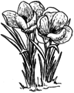

**Science and Social Studies**

We just finished talking about how communities change over time and are currently working on the states of matter. Do you remember what the three states of matter are?

Next, we will talk about rocks and soil, why they are important, and where they come from.

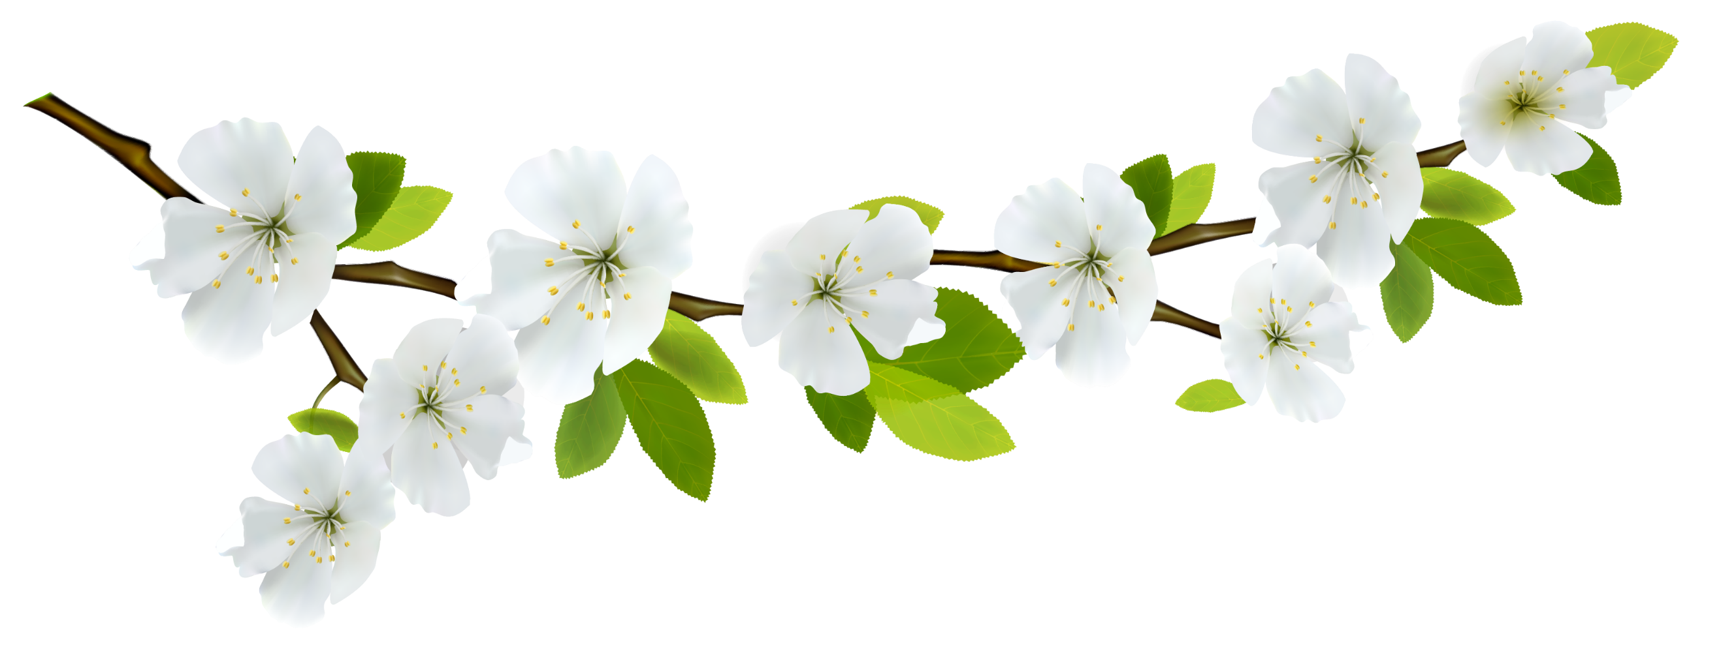

**February Wave Wonders**

***Brooklyn Cornette***

***Cheyanne Garner***

**Both students showed GRIT and perserverance**

**In March we are working to show responsibility.**